**Perennial Vegetables and Edible Ornamentals Seminar**

**Fun Quiz #1: Can you name these perennial edibles?**

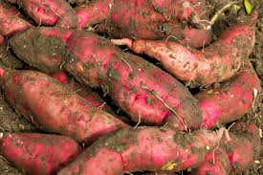

**© thespruce.com**

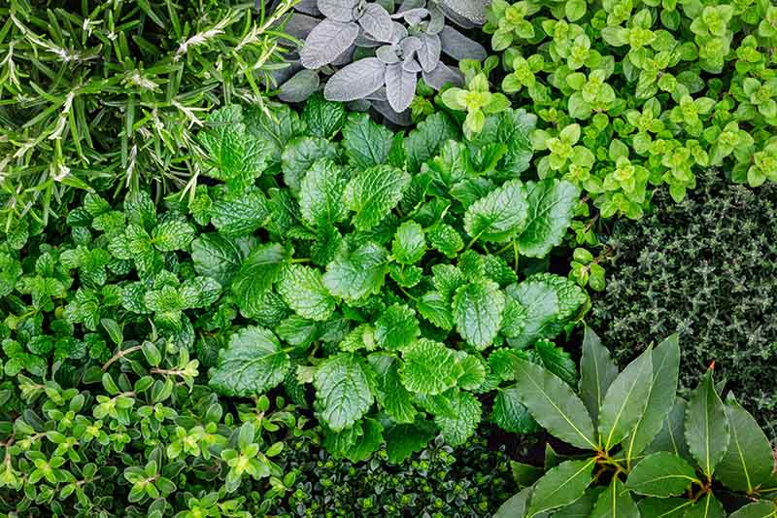

**© Gardener’sPath.com**

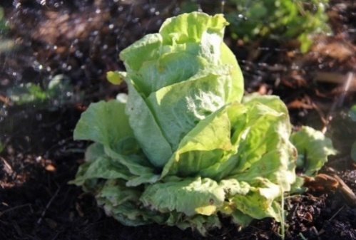

**© J. Canning**

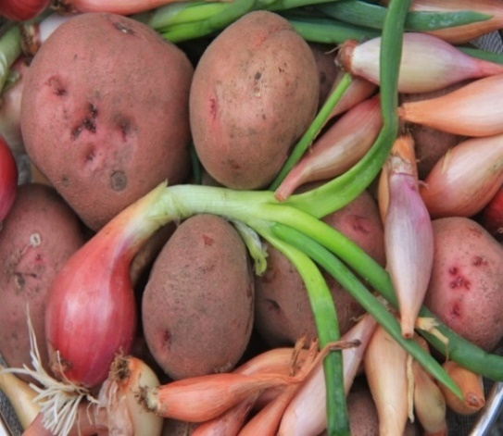

**© J. Canning**

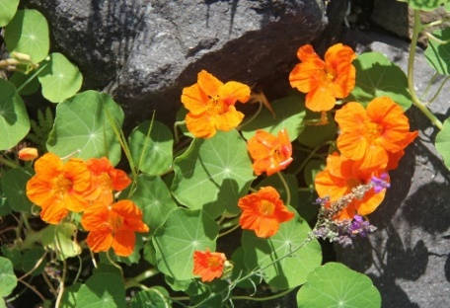

**© J. Canning**

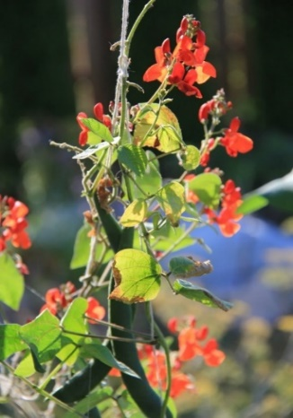

**© J. Canning**

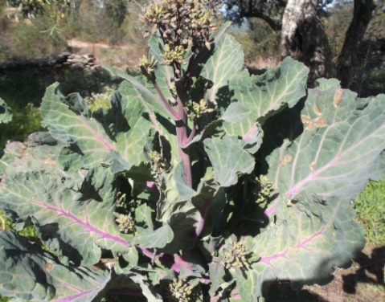

**© Permies.com**

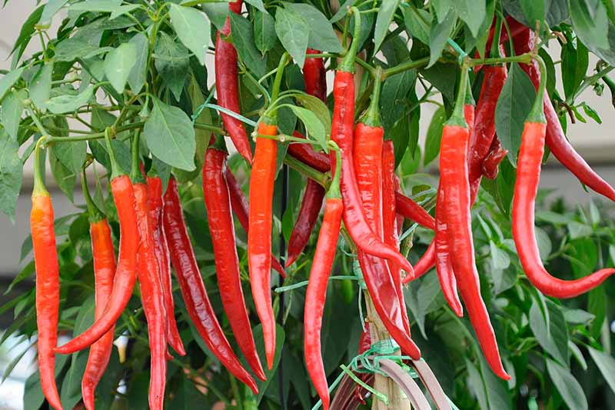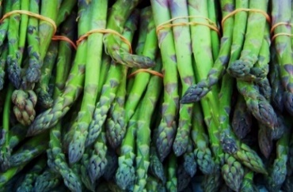

**stock photo, public domain**

**©GardenersPath**

❶

❷

❸

❹

❺

❻

❼

❽

❾

**Your Answers**

1 a) b) c) d) e)

2

3

4

5 a) b) c)

6

7

8

9

**Fun Quiz #2** **… What Parts of the Plant are Edible?**

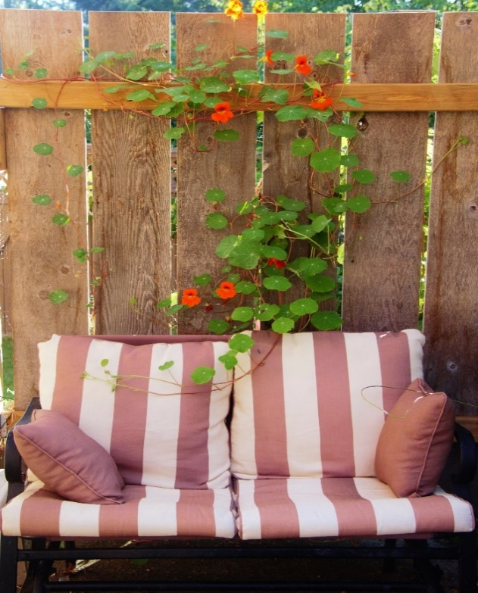

❺

© J. Canning

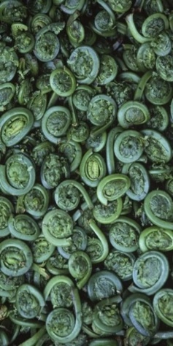

© cbc.ca

❹

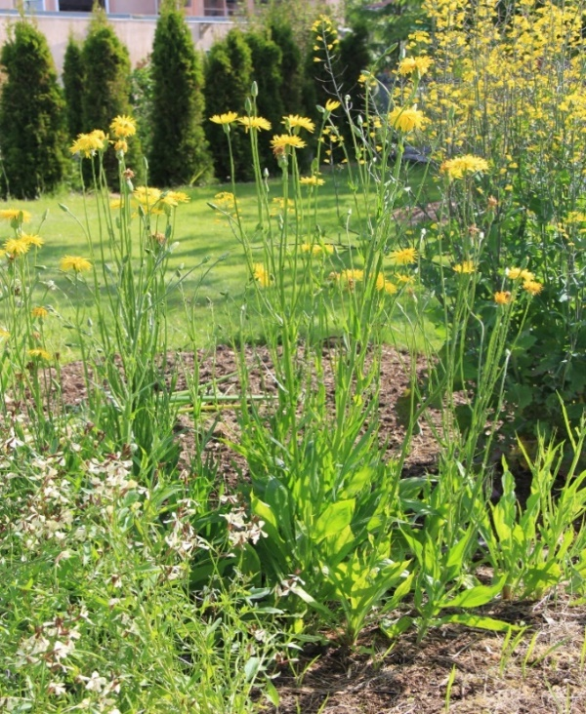

❸

**© J. Canning**

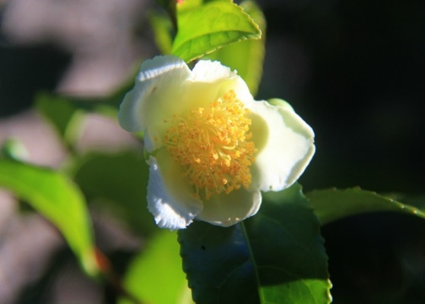

❷

© J. Canning

© J. Canning

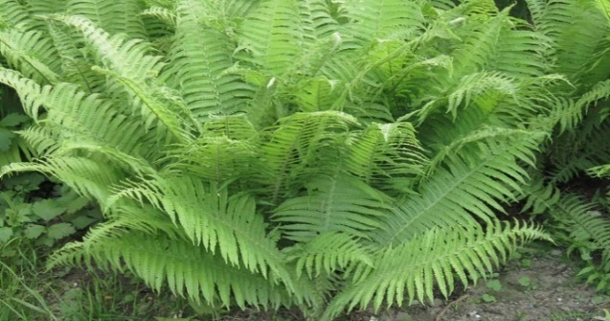

© g**ardenia.net**

❶

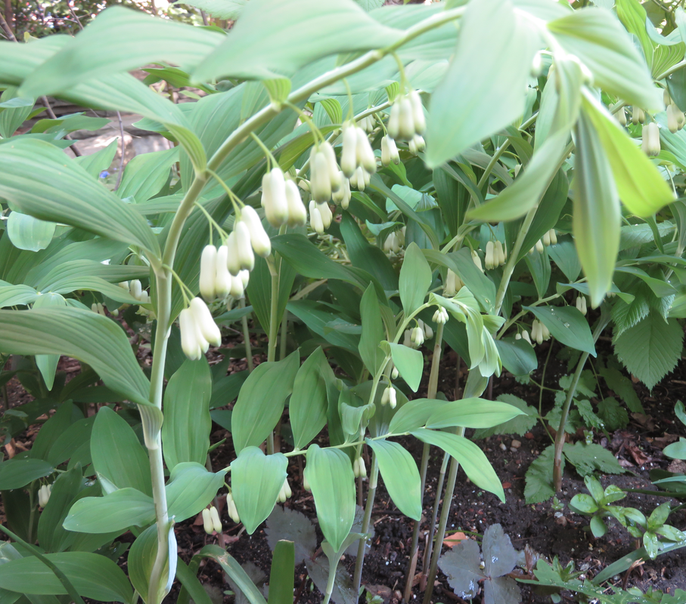

©UBC Botanical Gardens

❻

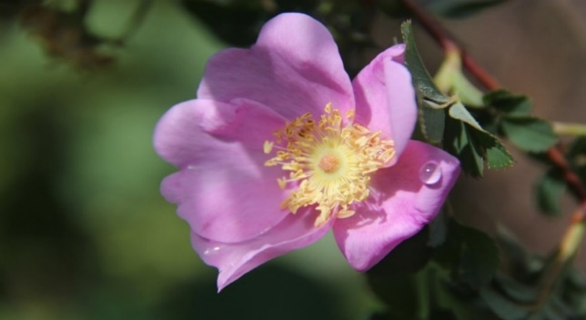

© J. Canning

❼

© J. Canning

***Answers next page…***

**Your Answers, Quiz #2**1

© J. Canning

© J. Canning

**© J. Canning**

2

3

4

5 a) b) c)

6

7______________________________________________________________

**Fun Quiz #1Answers**

1. Herbs: rosemary, mint, sage, oregano, thyme
2. Asparagus: spring fern stems
3. Nasturtium: leaves, stems, flowers
4. Runner beans (scarlet runner)
5. Potato and alliums (shallots, & top-set onions)
6. Hot chili peppers (chili de arbole)
7. Perennial kale
8. Sugarloaf chicory
9. Sweet potato (yam)

**______________________________________________**

**Fun Quiz #2 Answers What Parts of the Plant are Edible?**

1. Fern fronds – (image is *Athyrium filix-femina) the ornamental* lady fern, **NO!** (???)
2. Camellia species’ leaves and flowers – Yes, edible, but 2nd rate (???)  
   *Camellia sinensis* (image)– the tea plant (flowers, leaves, fresh, dried or fermented) **Yes,** the best tea!
3. Salsify / scorznera (*Scorzonera hispanica)* – flowers & mature leaves, **NO!**   
   Salsify tubers? Salsify young leaves, called “chards” …Yes, both mild and tasty.
4. Ostrich fern (*Matteuccia struthiopteris*), Yes, early spring “fiddleheads – Tasty, but must be cooked  
   …look-alike bracken fern (*Pteridium aquilinum),* eaten in Medieval times, **NO!** Considered toxic
5. Nasturtiums –flowers, stems, leaves – **Yes,** tasty!
6. Solomon Seal (*Polygonatum spp.)* – leaves, flowers, stems, seeds, **NO!**  
   … young shoots – **Yes,** tasty, asparagus alternative
7. Rose petals – **Yes!** All species’ petals used in tea, perfume, jellies, candy   
   (image is BC’s native plant, *Rosa nutkana*, the Nootka rose)

_______________________________________________________________________________________

**Plan For Change, One Plant at a Time**

1. Learn what edible perennials you already have
2. Taste each plant, and if you like the taste, which ones will you eat?
3. If so, move them to a permanent location in the garden
4. If not, will you keep it as: ornamental, use it as an annual, or a biennial, or get rid of it
5. Taste other edible perennials, and make a list of those you want & where to get them
6. Correctly identify the name of the plants / seeds you want, and their growing needs
7. Locate and prepare ahead of time a suitable place for one or more of them in the garden
8. Find trouble spots (boggy, shady, bad soil, too cold/hot), and see if something else on the list fits there

**Some Perennial Food Crops – Alphabetical List**

*NOTE: some plants on this list cannot survive low temperatures or frost, so know your climate zone*

**Vegetables, (leaves, stems, tubers & greens)**

Arrowhead, *Sagittaria sagittifolia*

Arugula, rocket, *Diplotaxis erucoides*

Artichoke, Globe, *Cynara scolymus*

Artichoke, Jerusalem, sunchoke, *Helianthus tuberosus*

Asparagus, *Asparagus officinalis*

Cardoon, *Cynaria cardunculus*

Card, Swiss, *Beta vulgaris ssp. vulgaris****\*\****

Chicory, *Cichorium* sp. (also herb)

Chili pepper*, Capsicum* sp. (most are annuals)

Comfrey, *Symphytum* sp. (also herb)

Garlic, *Allium sativum, A. ampeloprasum*

Ginger, *Zingiber officinale, Alpinia galangal*Ground nut, *Agrios americana*

Horseradish, *Amoracia* sp.

Kale, sea, *Crambe maritima*

Oca, New Zealand yam, *Oxalis tuberosa*

Onion, *Allium* sp.

Parsnip, *Pastinaca sativa*

Parsnip, Peruvian *Arracacia xanthorrhiza*

Pea, earth *Lathyrus tuberosa*

Peanut, *Arachis glabrata*

Potato, *Solanum tuberosum*

Rhubarb, *Rhuem rhabarbarum*

Scorzonera (black salsify), *Scorzonera hispanica*

Sea beet*, Beta vulgaris ssp. maritima*

Shallots, golden, *Allium cepa var. aggregatum*

“Shiso,” (Japanese Red Mint), *Perilla frutescens*

Sorrel, *Rumex acetosa*

Spinach, New Zealand, *Tetragonia tetragonoides*

Sweet potato (yam), *Ipomoea batatas*

Taro, *Colocasia esculenta*

Tomato, *Solanum lycopersicum*

Turmeric, Indian saffron, *Curcuma domestica*

Water chestnut, *Eleocharis dulcis*

Yacon, *Smallanthus sonchifolius*

**Trees & Shrubs**

Apple & crab apple, *Malus domestica*

Avocado, *Persea americana*

Black cherry, *Prunus serotina*

Chestnut, sweet, *Castanea sativa*

Cherry, *Prunus pensylvanica, P.virginiana*

Cherry, Cornelian, *Cornus mas*

Chokeberry, glossy, *Aronia melanocarpa*

Citrus, *Citrus* sp.

Redbud, Eastern, *Cercis occidentalis*

Fig, *Ficus carica*

Ginkgo (maiden air), *Ginkgo biloba*

Hawthorn, *Cratagus* sp.

Hazelnut ,*Corylus americana*, *C. cornuta, C. avellana*

Loquat, *Eriobotrya japonica*

Monkey puzzle*, Araucaria araucana*

Pear, *Pyrus* sp.

Persimmon, *Diospyros* sp.

Plum, *Prunus* sp.

Quince, *Cydonia oblonga*

Serviceberry (Juneberry), *Amelanchier* sp.

Walnut, *Jungalans* sp.

**Herbs**

Anise, hyssop, *Agastache foeniculum*

Basil, *Ocimum basilicum*

Catnip, *Nepeta cataria*

Chives, *Allium schoenoprasum, tuberosum, ramosum*

Fennel, bulb, leaf, *Foeniculum vulgare,* F. v. *'purpureum'*

Feverfew, *Chrysanthemum parthenium*

Lavender, *Lavandula angustifolia*

Lovage, *Levisticum officinale*

Mint, *Mentha* sp.

Oregano*, Origanum vulgare*

Parsley, *Petroselinum crispum* ***\*\****

Rosemary, *Rosemarinus officinalis*

Sage, *Salvia* sp.

Tarragon, *Artemisia dranunculus*

Thyme, *Thymus vulgaris*

**Vines**

Beans, scarlet runner, Phaseolus coccineus

Grape, River (native N.A.), *Vitis riparia*

Grape, Table and Wine, *Vitis* sp.

Kiwi, *Actinidia* sp.

**Berries**

Blackberry, *Rubus allegheniensis, R. ursinus*

Blueberry, *Vaccinium angustifolium*, *V. corybosium*

Cranberry, *Vaccinium macrocarpon*

Cranberry (N. A. highbush), *Viburnum trilobatum*

Currants, *Ribes aureum* and sp.

Elderberry, *Sambucus nigra, S. canadensis*Raspberry, *Rubus occidentalis* and sp.

Rose, *Rosa* sp. and hybrids

Sumac, smooth, & staghorn *Rhus glabra, typhina*

Strawberry, *Fragaria* sp.

Thimbleberry, *Rubus parviflorus*  
***\*\* (biennial, forced to short-lived perennial***

**A short list of some perennial vegetables edible parts**

**Tubers**  
- potato  
- garlic  
- daylily  
-dahlia  
-sunchoke  
-scorzonera & salsify  
- Solomon’s seal  
-lotus  
- water chestnut  
- peanuts  
(also American groundnut)

**Salad (raw greens)**- burnet  
- lemon balm  
- chives & scallions

- fennel leaves  
- radicchio  
- nasturtium leaves & stems  
- dandelion  
- kale  
- watercress  
- pennywort  
- opuntia (pads also cooked

**Greens (cooked)**- cardoon  
- scorzonera  
- sorrel  
- nettles  
- hosta  
- sugarloaf chicory  
- duckweed

- nettles

**Seeds / Legumes**(usually dried & stored)- runner beans  
- wild peas (not perennial sweet pea!)  
- chickpeas (garbanzo)  
- peanuts (& American groundnut)

**Stems (cooked)  
-** garlic scapes  
- asparagus  
- daylily  
- fiddlehead fern  
- lotus  
- pennywort

- rhubarb

**Flowers (to name just a few!)**  
- globe artichoke  
- pansies  
- daylily (stuffed & fried)  
- broccoli (perennial)  
- nasturtiums  
- rose petals  
-violets  
- dahlia

**__________________________________________________________________________**

**VIRL Book List(**Note: ** means not available at VIRL)

* **Extraordinary ornamental edibles: 100 perennials, trees, shrubs and vines for Canadian gardens** by Mike Lascelle
* **The Food Forest Handbook: Design and manage a home-scale perennial polyculture garden** (2017)

by Darrell Frey & Michelle Czolba

* **Gardening like a ninja: A Guide to Sneaking Delicious Edibles Into Your Landscape**

by Angela England

* **How to grow perennial vegetables** (2012)

by Martin Crawford

* **Perennial Vegetable Gardening** [DVD]

with Eric Toensmeier

* **Growing Perennial Foods: A Field Guide to Raising Resilient Herbs, Fruits, & Vegetables** (2019)

by Acadia Tucker

* **\*\*Edible Perennial Gardening: Growing Successful Polycultures in Small Spaces**, 2014,

by Anni Kelsey

**Suggested Web Sites**

**How-to sites:**

* https://www.thespruce.com/how-to-start-a-permaculture-garden-4050110
* https://davidsuzuki.org/queen-of-green/how-to-grow-edible-perennial-plants
* https://www.ecohome.net/guides/2232/a-guide-to-growing-edible-perennials/

**Where to buy seeds & plants**

* Oregon company, ships to Canada: https://www.restorationseeds.com/
* International sources, including Canada: https://www.etsy.com/market/perennial_vegetable

**For Facebook folks**, here is a local company:

https://www.facebook.com/pg/smallislandseedco/posts ­­­­­­­­­­­­­­­­­­­­­­­­­­­

______________________________________________________________________________________